Visualizing Vancouver: Meeting the City’s 2040 Traffic Goals

SDA 490 - Supplementary Long Form Data Visualization

Steve Weldon & Edana Beauvais

April 12th 2023

Matthew Horstead, Dustin Poon, Amir Al Kowshik

**Introduction and Importance**

As the population of Vancouver continues to grow, so too does the number of vehicles on our roads. This increase in traffic not only contributes to congestion and delays but also has significant implications for the environment and public health. To ensure a sustainable future for our city, we need to consider how we can shift towards more sustainable modes of transportation, such as biking, walking, and public transit. In this data visualization, we will explore the current state of traffic in Vancouver, predict what traffic might look like in 2040, and propose strategies for achieving a more sustainable transportation system.

Throughout this article the topic of traffic within the lower mainland is explored heavily, more so the variables that cause traffic, alongside the potential steps that may be taken towards mitigation and effective optimization for the future of Vancouver.

**Crash Data**

In this section, we will explore the locations where crashes are most likely to occur. Using ICBC crash data, we found that the majority of crashes are most likely to occur at the intersections as well as entry and exit points of highways.

To visualize this information, we created a map that shows the frequency of crashes in different areas:

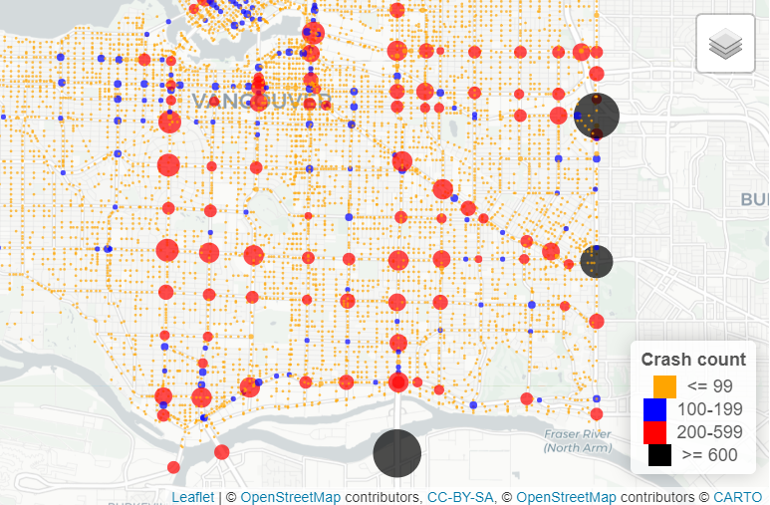

We found that large multi-lane intersections, especially those with complex traffic patterns, are a hot spot for crashes. These intersections often require drivers to navigate multiple turning lanes and merge with oncoming traffic, making it difficult to maintain situational awareness and avoid collisions. Additionally, intersections located near busy commercial or residential areas may have high volumes of pedestrians and cyclists, further increasing the risk of accidents. For example, image below on Boundary road and Grandview Highway.

Image 2:

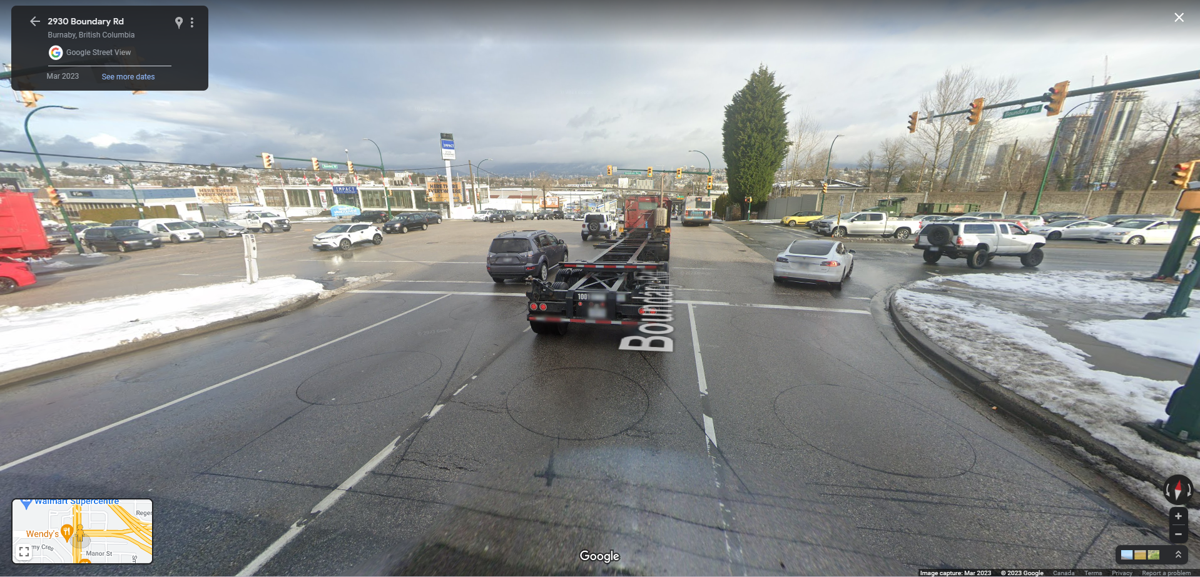

Entry points of highways can also be dangerous areas for drivers. These areas are typically designed to allow vehicles to merge onto highways at high speeds, which can be challenging for some drivers.

Finally, sloped streets can also be hazardous, especially during inclement weather conditions. The combination of steep inclines and slippery road conditions can make it difficult for drivers to maintain control of their vehicles, leading to collisions.

In conclusion, the highest count of crashes in Vancouver occurs in areas where drastic speed changes occur, such as highway entrances and exits, large multi-lane intersections, bridge entrances and exits, and sloped streets. Keeping in mind, the coming influx of new Canadians with new drivers licenses may be a factor for the city to consider for the future development of road networks in Vancouver. Addressing these high-risk areas through road design improvements, increased enforcement, and public education campaigns could help reduce the incidence of crashes and improve traffic safety in Vancouver.

**“Greens” Phenomenon**

Another interesting finding from the ICBC crash data is the "Greens" phenomenon. It has been observed that traffic incidents that occur near and around "green" areas, such as public parks, golf courses, and playgrounds, seem to happen to a much lesser extent than in other areas.

This phenomenon is thought to be a result of several factors. Firstly, green areas tend to have lower speed limits and more appropriate traffic signals, which help to reduce speed-related accidents. Additionally, these areas often have better sightlines for drivers, allowing them to better anticipate potential hazards and avoid collisions.

It’s important to note that something unique is happening in these areas, which is contributing to the lower incidence of crashes. Further research is needed to identify the specific factors at play and determine how they can be replicated in other areas to improve traffic safety overall.

One possible explanation for the "Greens" phenomenon is that these areas are designed with pedestrian and cyclist safety in mind. For example, many public parks and playgrounds have dedicated paths and crosswalks for pedestrians, making it easier for them to move around safely, further deterring traffic. Similarly, golf courses may have designated cart paths and signage to ensure that drivers are aware of pedestrians and cyclists sharing the road.

In conclusion, the "Greens" phenomenon observed through the ICBC crash data suggests that green areas may have unique characteristics that contribute to lower incidence of crashes. By studying these areas and identifying the specific factors at play, we may be able to replicate their success in other areas and improve traffic safety across Vancouver.

**Exogenous Variables**

Furthermore, investigation of other factors unrelated to crashes, but related to traffic movement throughout Metro Vancouver is important to consider.

**Job Market allocation**

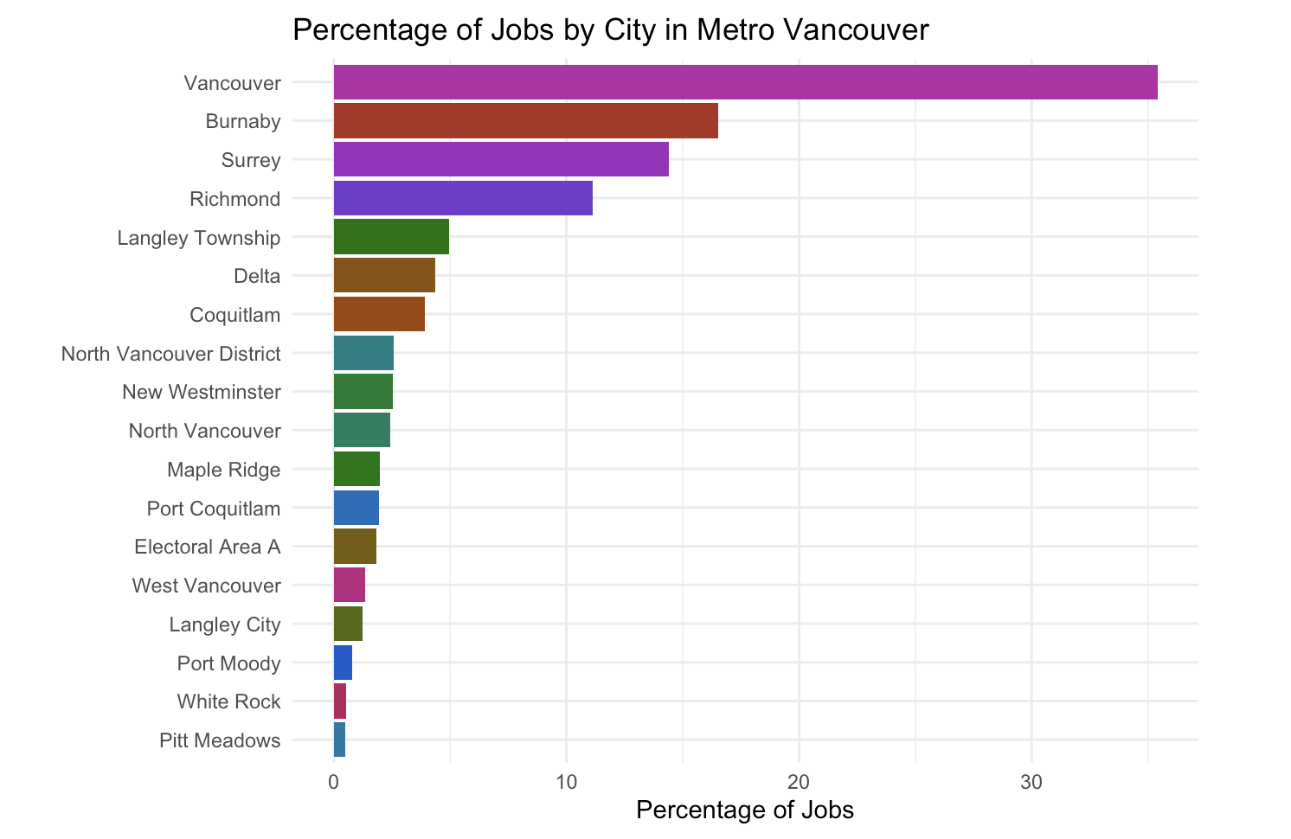

Anotherimportant variable in trying to understand the movement of traffic within Vancouver would be the portion of total jobs that require workers to be in Vancouver. Vancouver currently has approximately 35 percent of all jobs in the lower mainland, meaning many people find themselves traveling in and around Vancouver, despite not residing there.

**Average Kilometer Traveled per Vehicle per Capita**

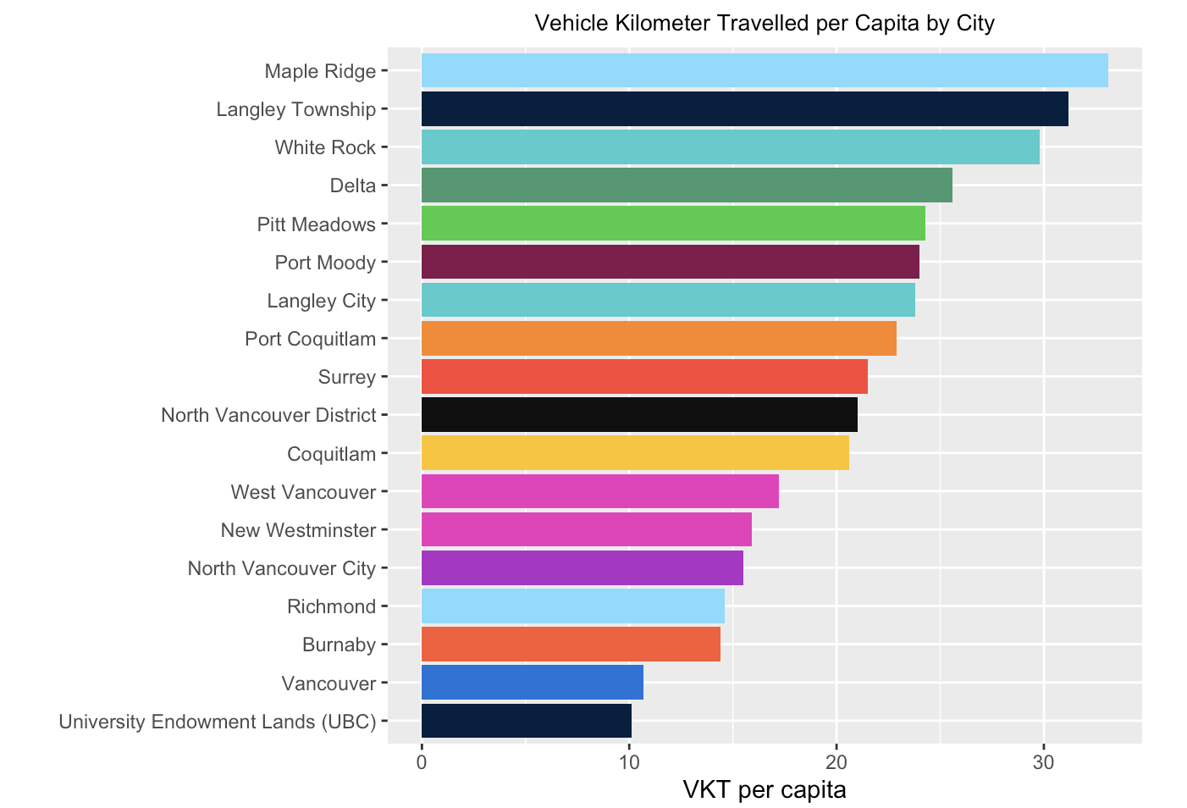

Additionally, another important factor that was hypothesized to be affecting travel as well as transit usage in the lower mainland is the average travel distance per city per capita. Cities such as Langley, Maple Ridge, as well as Abbotsford face extremely long driving distances for work, with reduced transit accessibility. This leads to an influx of vehicles on the road.

**Causes of Fatalities**

According to the statistics from British Columbia's government, speeding was the leading cause of fatalities in the province from 2010 to 2019, except for the year 2018. While it is unclear from the data why speeding was not the leading cause in 2018, it is important to note that all of the other causes listed, such as aggressive driving, distracted driving, and impairment, can also contribute to fatal accidents on the roads. It is crucial for drivers to follow all traffic laws and to drive defensively to help reduce the number of fatalities on the roads. Additionally, maintaining a safe speed is a critical part of safe driving, and drivers should always adjust their speed according to weather, traffic, and road conditions.

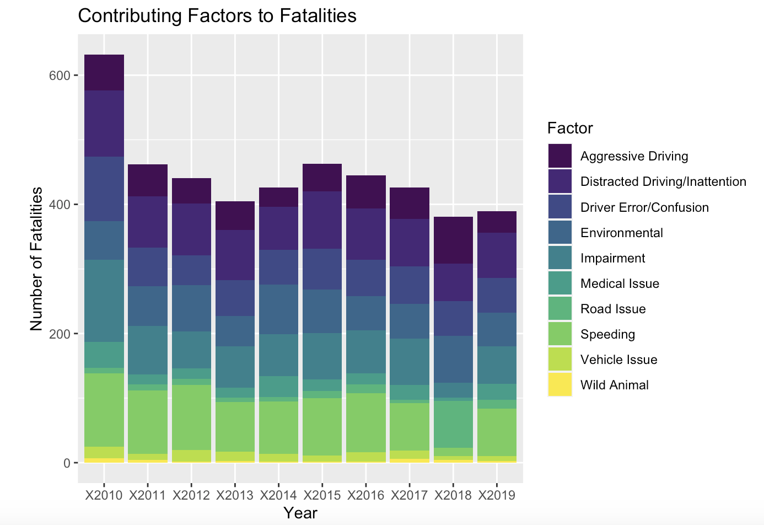

**Crime per capita**

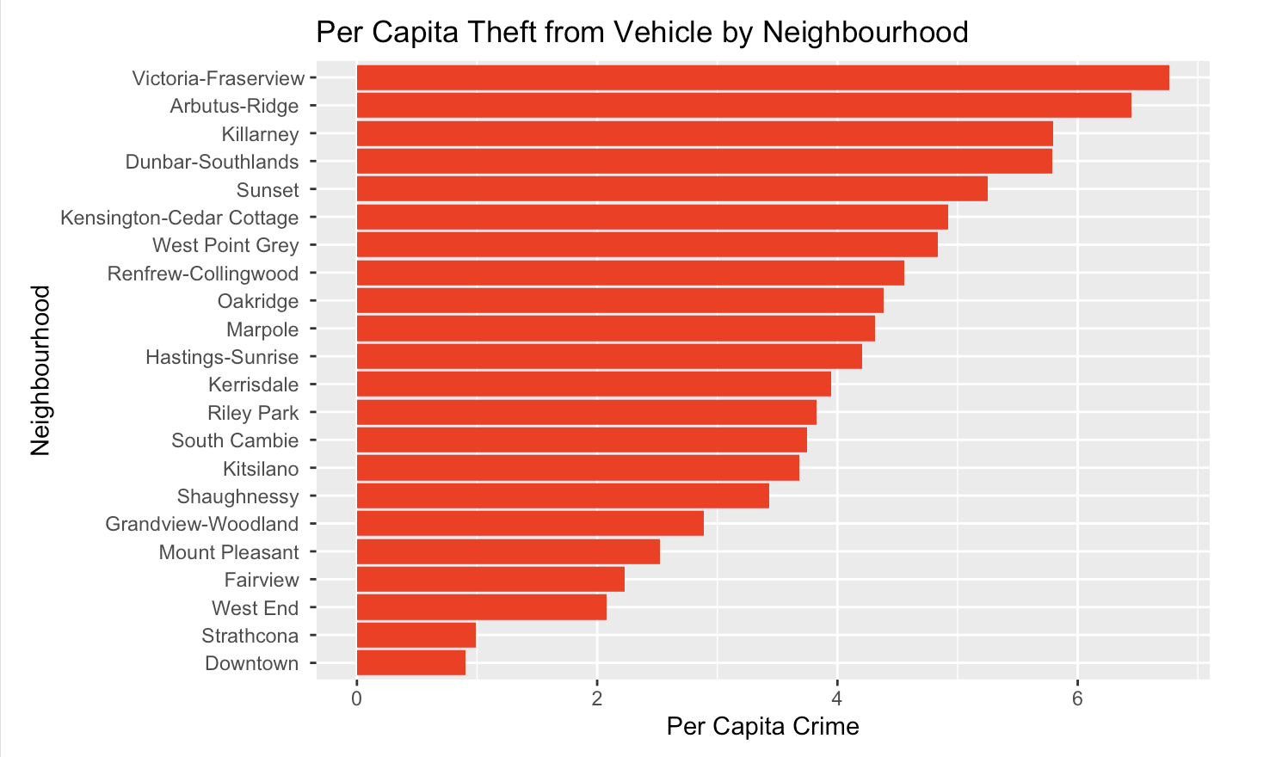

The crime data from the Vancouver Police Department indicates that the downtown area of Vancouver has the highest number of reported theft from vehicles compared to any other neighborhood in the city, with a count of over 68,000 incidents. Although downtown is considered a safe area in terms of per capita crimes, the high number of thefts from vehicles is a cause for concern. The fact that downtown is home to many large corporations and is a major employment hub for Metro Vancouver likely contributes to the high number of vehicles in the area, and therefore, the high incidence of theft from vehicles. However, it is also important to note that vehicle traffic can impact crime rates, as evidenced by the trend in theft from vehicle incidents over the years. From 2011 to 2019, there was a positive growth in crimes, with a sharp decline in cases reported in 2020 and 2021. It is reasonable to assume that the work-from-home office culture during the pandemic could have affected these numbers. Nonetheless, it is crucial for individuals to take precautions, such as not leaving valuables visible in their vehicles, to reduce the likelihood of becoming a victim of theft from vehicle crimes.

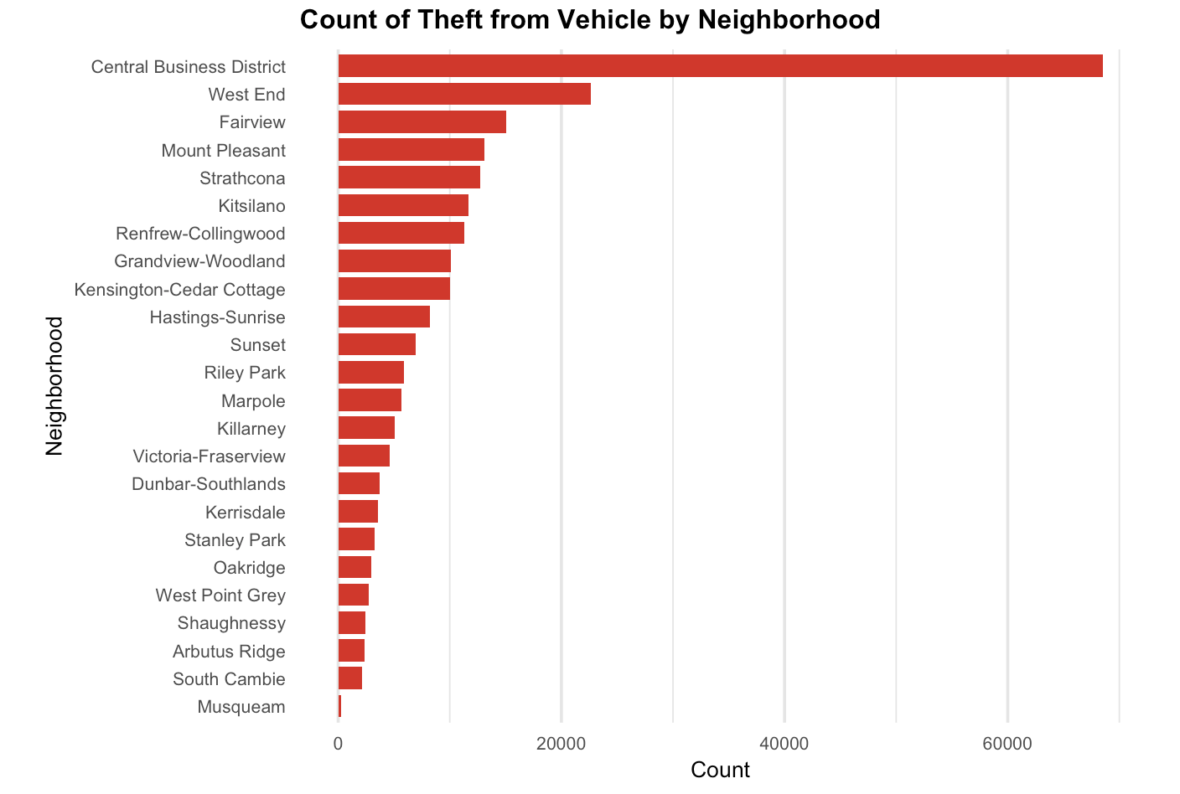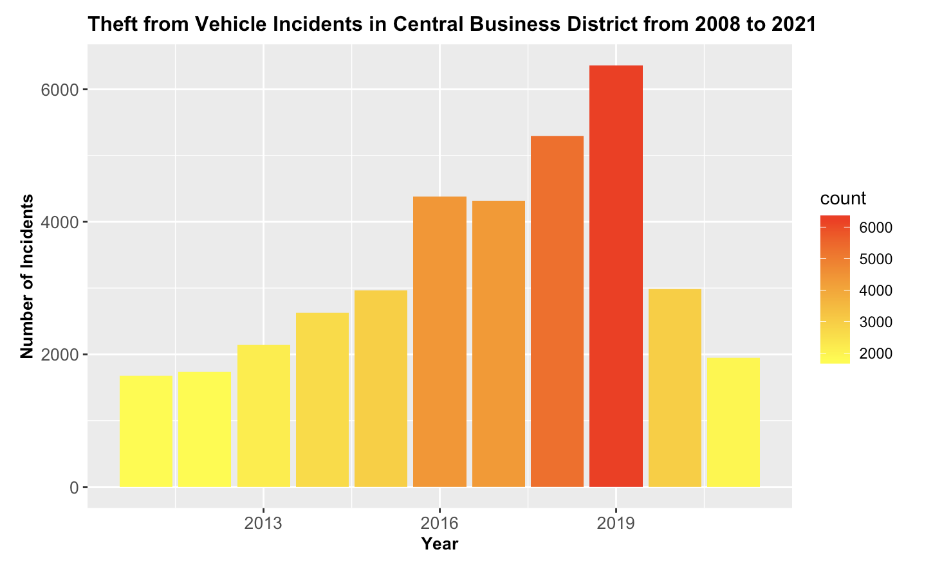

**Textual analysis**

The utilization of textual analysis was an idea that was centered around trying to better understand the opinions of real humans instead of relying exclusively on quantitative data as has been the primary data type thus far. The hope was to provide a more robust understanding of not only the physical aspects of traffic in Vancouver, but also the opinions of people directly affected by it.

**Scraping and uses**

Scraping data off of websites like twitter.com and reddit.com were vital for sourcing textual data, due to the abundance of highly searchable and customizable opinionated textual data. Selecting sources such as Vancouver specific subreddits and twitter hashtags was most important for narrowing down searches to relevant data for analysis.

**Sentiment Analysis and Emotion Classification**

After investigation of the large scraped text files, it’s noted that the opinion data (centered around Vancouver citizens' thoughts and feelings towards traffic) was more negative in sentiment than positive. Interestingly, not overwhelmingly negative though. This could do with the type of natural language processing lexicon the emotional classifier used. By using both the “AFINN” and “NRC” lexicons, it is clear that perhaps these lexicons overestimate positive sentiment by default and need to be adjusted accordingly.

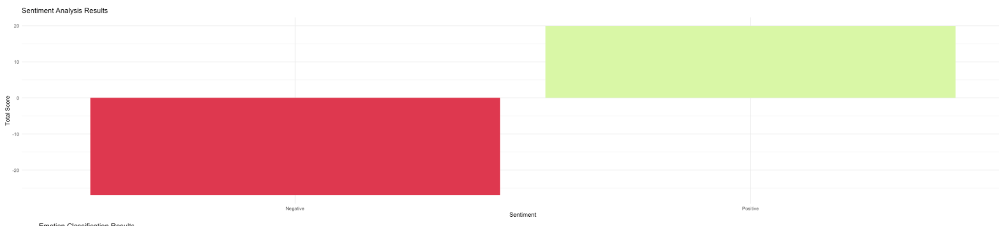

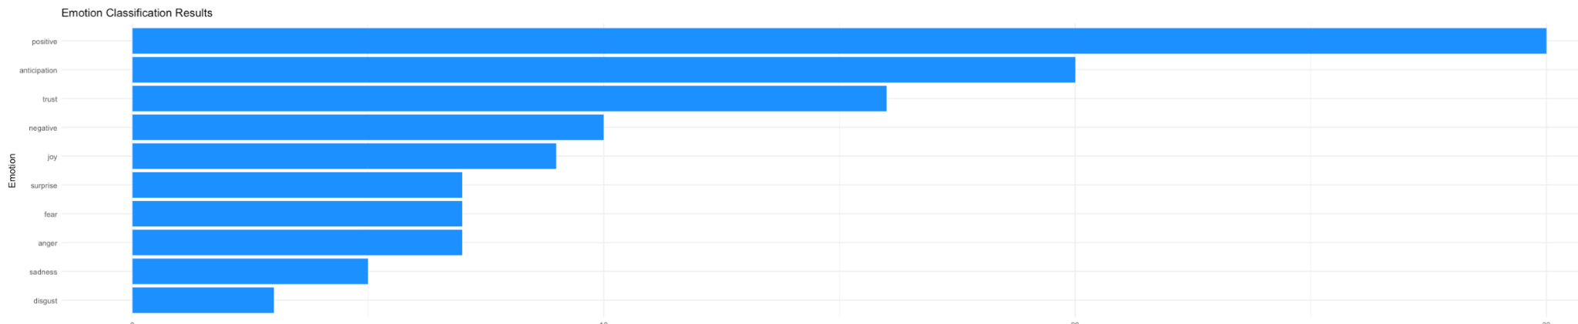

**Reddit word cloud Generator**

Using sentiment analysis and emotional classification tools is an interesting way to derive understanding of the core emotions humans feel towards a certain subject matter, however it fails to provide a clear commonality across all the text, that being the most common topics that are being analyzed. By developing the reddit.com word cloud generator, many common themes were found across many different “reddit.com/r/vancouver /" threads. The most commonly discussed traffic topics within the subreddit included “traffic”, “lanes”, “downtown”, “bike", “drivers”, and more. By combining these three tools for textual analysis we found that overall there is a widely shared negative sentiment towards much of the infrastructure based in Vancouver, BC. This helped to cement the idea that Vancouver truly needs help when it comes to city planning for the future.

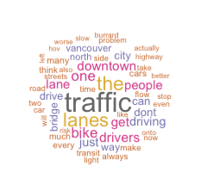

**Bias**

When working with this type of data it’s important to note that it is extremely biased by nature. When people want to complain they typically choose to do it on the internet, however when they wish to praise something they will choose to keep it to themselves, or discuss it through word of mouth. Our aim was to collect enough data so that this bias would be as minimized as possible, due to the sheer amount of content to be analyzed, however it is still important to acknowledge this discrepancy. A predisposition for textual data scraped off the internet to be slightly more negative by default, rather than neutral, is definitely a factor that needs consideration when analyzing textual data.

**Conclusion and Final Remarks**

In conclusion, after all considerations this research group has come up with several potential solutions with the goal of minimizing traffic in Vancouver.

Firstly, the culture of working from home and opting to telecommute into work is a growing phenomenon, in which the COVID-19 pandemic played a catalyzing role in the emergence of both distance work and education. By further incentivizing online commutes for those who find themselves spending many hours in a vehicle, this can help to reduce traffic as a whole and provide marginal benefits for all those affected.

Secondly, by investigating the phenomenon of reduced traffic related accidents occurring near open public spaces known as “greens”, an attempt to replicate this across a wider cityscape may be a potential solution, or at least consideration.

Thirdly, since Vancouver is expecting a large influx of new British Columbians over the next 20 years, now is a critical time for city developers and planners to take action. Our group's suggestions include focusing on developing another central business area outside of the City of Vancouver in which new jobs may be made for the increasing population, in addition to relocating current jobs within Vancouver to outside of the city, closer to home for those who face greater kilometer traveled per capita. Another obvious solution would be to propose “build a new skytrain line” however, this may be intangible at the moment as the city is focused on effective policy changes rather than drastic public infrastructure projects.

Lastly, the best way to mitigate traffic in and around Vancouver is to educate oneself. The data dashboard’s overall aim of assisting in educating the public of the state of Vancouver traffic with the hopes that one will be able to make educated decisions for one's own sake. By lowering the barrier to entry for learning about how traffic moves within Metro Vancouver we hope to have inspired others to rethink their commuting habits.